ONEWAY Memory BY RES
/STATISTICS DESCRIPTIVES HOMOGENEITY WELCH
/PLOT MEANS
/MISSING ANALYSIS.

Oneway

Notes
Output Created |  | 06-May-2019 00:03:34
Comments
Input | Active Dataset | DataSet0
Input | Filter | <none>
Input | Weight | <none>
Input | Split File | <none>
Input | N of Rows in Working Data File | 30
Missing Value Handling | Definition of Missing | User-defined missing values are treated as missing.
Missing Value Handling | Cases Used | Statistics for each analysis are based on cases with no missing data for any variable in the analysis.
Syntax |  | ONEWAY Memory BY RES  /STATISTICS DESCRIPTIVES HOMOGENEITY WELCH  /PLOT MEANS  /MISSING ANALYSIS.
Resources | Processor Time | 00 00:00:00.156
Resources | Elapsed Time | 00 00:00:00.167

[DataSet0]

Descriptives
 | N | Mean | Std. Deviation | Std. Error | 95% Confidence Interval for Mean
 |  |  |  |  | Lower Bound | Upper Bound
1360x768 | 7 | 87.3414 | 16.46699 | 6.22394 | 72.1120 | 102.5709
1920x1080 | 15 | 77.2467 | 25.95102 | 6.70052 | 62.8755 | 91.6179
800x600 | 8 | 132.7500 | 27.47856 | 9.71514 | 109.7773 | 155.7227
Total | 30 | 94.4030 | 33.66618 | 6.14658 | 81.8318 | 106.9742

Descriptives
 | Minimum | Maximum
1360x768 | 67.50 | 106.25
1920x1080 | 48.00 | 162.00
800x600 | 75.00 | 166.00
Total | 48.00 | 166.00

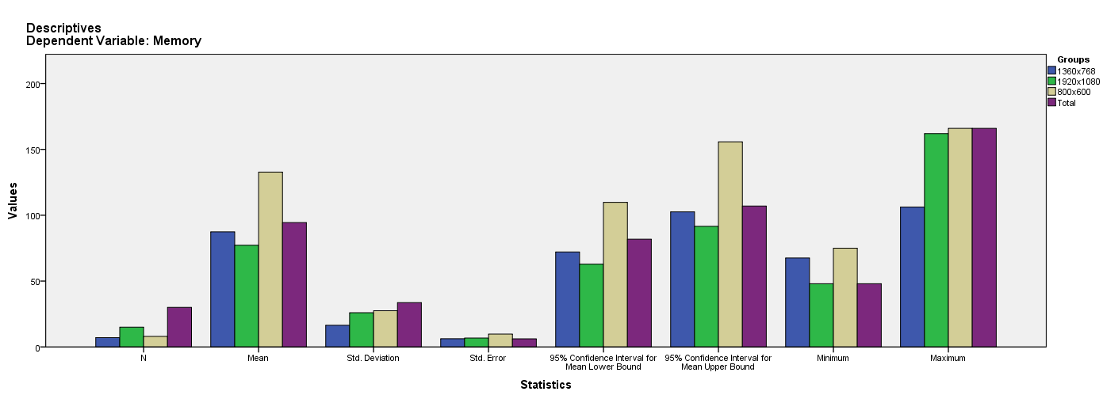

Test of Homogeneity of Variances
Memory
Levene Statistic | df1 | df2 | Sig.
.124 | 2 | 27 | .884

ANOVA
Memory
 | Sum of Squares | df | Mean Square | F | Sig.
Between Groups | 16528.096 | 2 | 8264.048 | 13.655 | .000
Within Groups | 16340.848 | 27 | 605.217
Total | 32868.945 | 29

Robust Tests of Equality of Means
Memory
 | Statisticª | df1 | df2 | Sig.
Welch | 11.015 | 2 | 15.176 | .001
a. Asymptotically F distributed.

Means Plots

